William S. Hart on DVD: The Bargain
Bill West
Welcome back pardners, to our next stroll into the DVD offerings of William S. Hart. Last article, we talked about the availability of William S. Hart movies on DVD – perhaps there were more than you expected – and a few comments on the wonderful William S. Hart movies in general. Starting with this article, we will visit each of the DVDs, in the order in which Bill made them. This article will feature Bill’s first full-length motion picture, The Bargain. And, if you stick with me to the end of the article (I do tend to get long winded on this subject), we’ll talk about a bargain you can get if you decide to purchase The Bargain.
But before I get to The Bargain (I warned you that I tend to go on a bit), I’d like to update the previous article with some additional information:
- Last article I mentioned that I had just ordered “Wagon Tracks” as well as the only surviving reel from “Riddle Gawne” which was on a Mabel Normand DVD called “Suzanna.” I had gotten them from Amazon.com. Well, unbeknownst to me, they are in the DVD-R format (as is The Bargain, by the way), not plain DVD. Most recently produced DVD players will play them, but you should check your owner’s manual to be sure before purchasing these. I also learned that they can be purchased directly from the company that produces them: www.unknownVideo.com (neat name, huh?) Lastly, they each come with a little refrigerator magnet featuring a play bill from a silent movie. Below are the ones I got. They’re on our fridge for keeps!
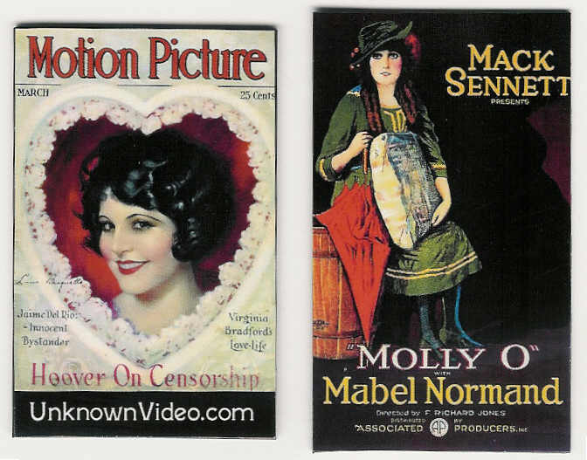
- Next, one of our fine Hart board members and a dedicated volunteer, Jeff Wheat, dropped me a line after my last article, and mentioned a movie I had missed. “Hell’s Hinges” is available on a collection called “Treasures from American Film Archives: 50 Preserved Films.” My favorite DVD dealer, www.DeepDiscountDVD.com has the set for $51.17. Thanks for the tip Jeff, and great timing! Since I’m going through Bill’s DVDs in chronological order, Hell’s Hinges is next!
Now (finally!), on to The Bargain… I was so thrilled to find Bill Hart’s first movie!... except, well, that’s not quite true. It’s his first full length movie. Before that, he made two shorts (2 reelers) where he wasn’t the headlining star as he would be in every film from The Bargain on. Also, unlike his future films, these were like the others of the time, meaning historic accuracy was not a priority.
The shorts were called “His Hour of Manhood” and “Jim Cameron’s Wife.” I wish these were on DVD, if only because Bill Hart hated them! He thought his acting was awful. Sure enough, the critics didn’t care for the movies much either (they hated the first and merely tolerated the second), though they did concede that Bill did an adequate job.
But I’m still not talking about The Bargain, and my wife Liliana, the designer of this newsletter, has warned me that my planned article is too long, enough to take up the whole newsletter. So I’d better stop scootin’ around the topic! So, without further ado, The Bargain….
Now, Bill had come to California at the suggestion of the man who would become the producer of many of Bill’s films, Thomas Ince. Bill managed to join a play that would be traveling to California just to get here on the cheap. But after making these two clinkers, Bill told Ince he was going back east if he couldn’t make films his way. Besides, Bill wanted to make a full length picture.
Ince tried to calm him down, saying he had an idea for a third film, but it wasn’t long enough to be a feature. Bill took a look at the story and asked Ince if he could have it for a few days to “build it up” some. And just a few days later, Bill returned it, doubled in length, with a much fuller, more interesting treatment on the story. Ince was excited, and hired writer C. Gardner Sullivan to turn their story into a script.
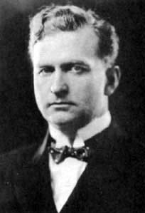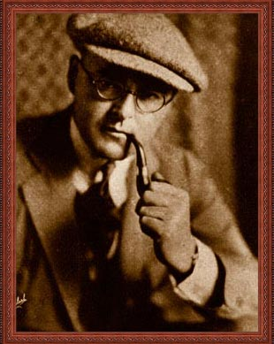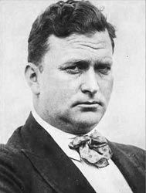
Producer Thomas Ince Director Reginald Barker Writer C. Gardner Sullivan
Now here’s something that surprised me about the film. Bill played his “good bad guy” character which he was famous for much later. In this case, he was a stage coach robber who fell in love and tried to make things right. This became a classic formula for Bill, and with his acting ability, he pulled it off every time! Another thing that was iconic about Bill that started in The Bargain: his character was called “The Two-Gun Man!” In fact, the 1920 reissue title was “Two-Gun Man in the Bargain.”
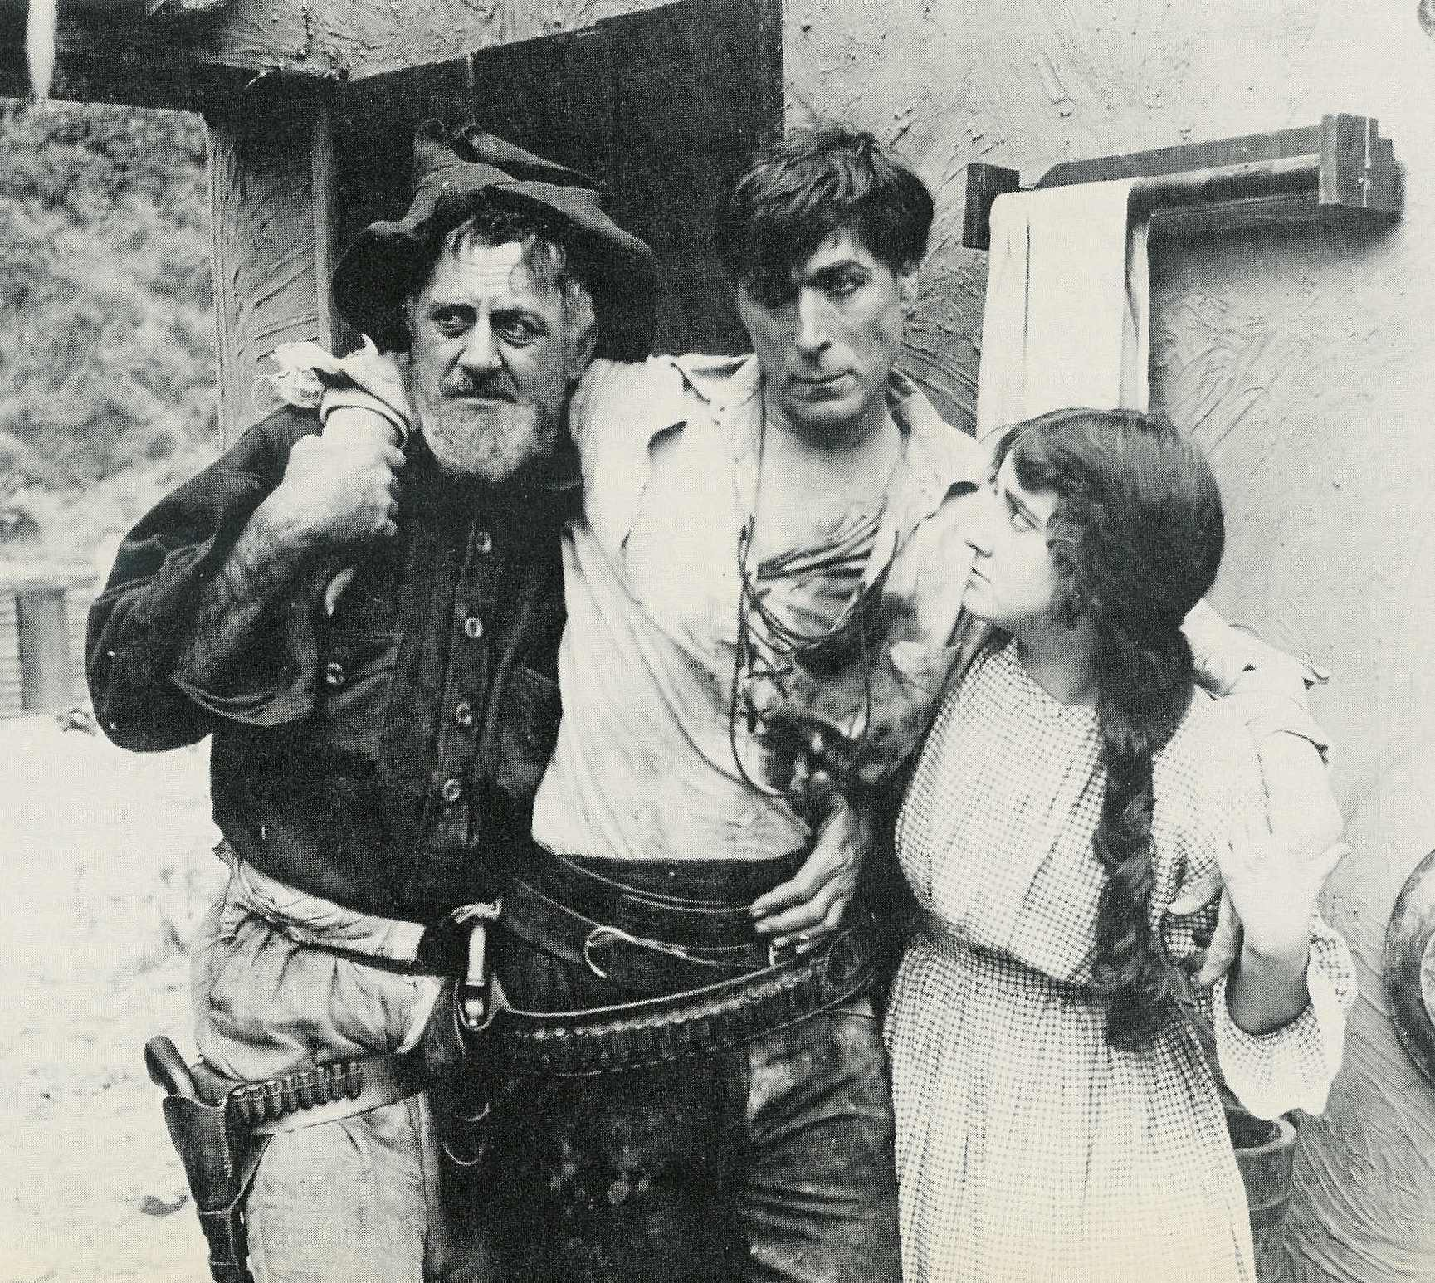
Bill with his love and her father
The movie has a witty scene where Bill robs a stage coach. I don’t want to give it away, but it’s a pretty clever plot point, and I wonder if this scene was one of Bill’s contributions.
The movie has incredible scenery with almost a John Ford sense of vistas. This was important to Bill, and he promoted filming part of the Bargain in the Hermit Creek Trail area of the Grand Canyon. He said it cost about $600, and his grease paint makeup melted in the Arizona sun, but the result was a fine looking film. Bill was quoted as saying “Golly! What a corking trip it was.”
Bill rode a horse named Midnight (which had injured cast members, but Bill could ride him without a problem) along steep cliffs and at a gallop so fast the cameraman could barely keep up! Midnight is in another of the amazing scenes in this film. He is shown heading toward a cliff, and thru some skillful cutting with a scene of the horse rolling down a hill, it really looks like Midnight went over the cliff.
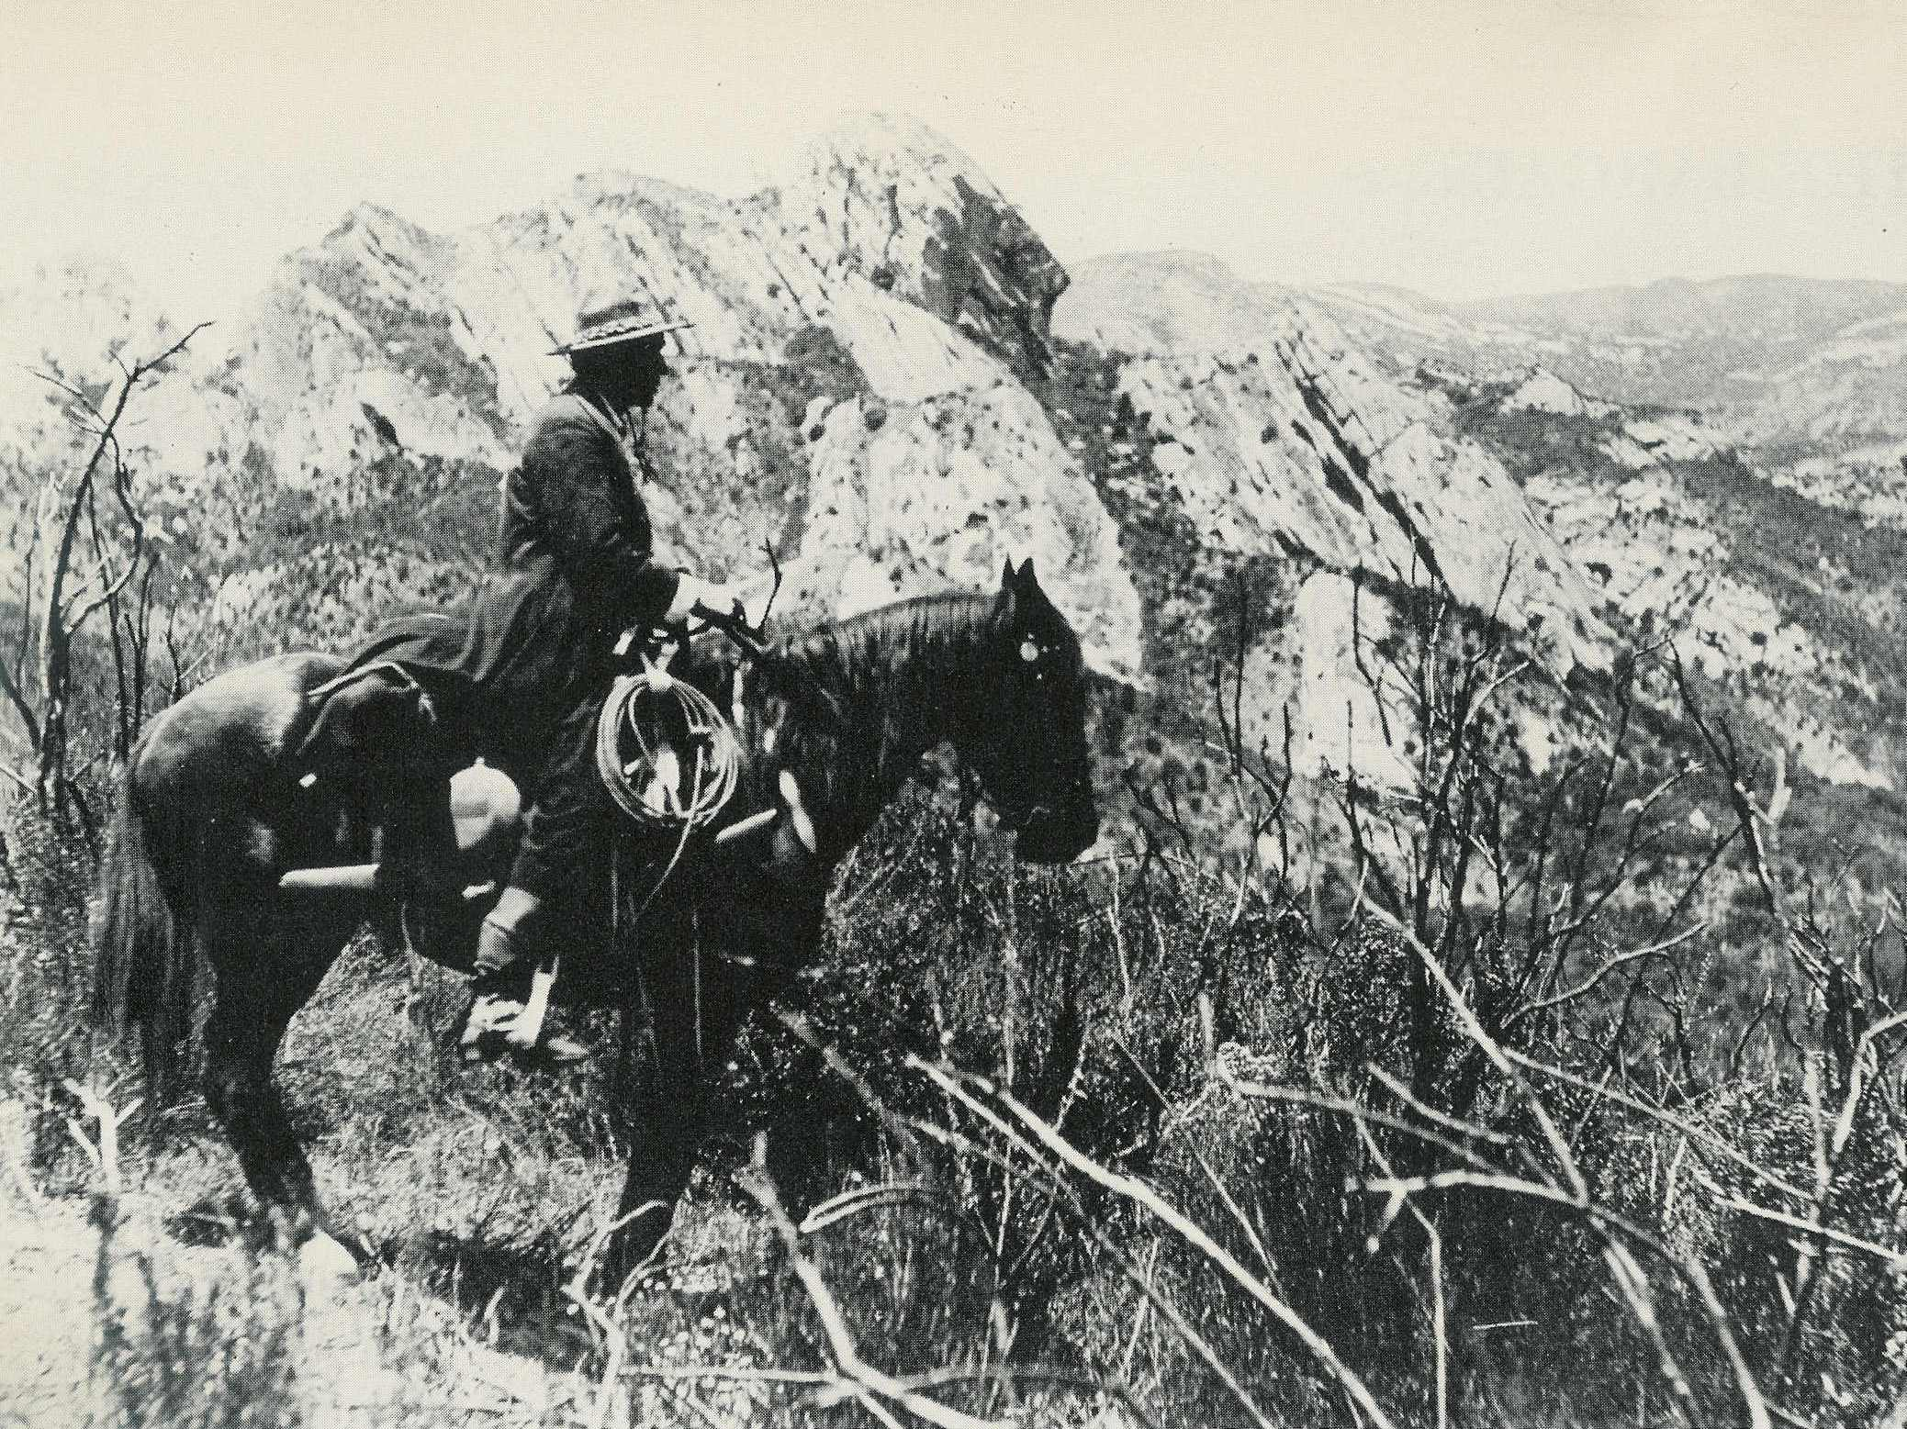
Bill & Midnight at the Grand Canyon
Another surprising thing about the film is its interesting use of flashbacks. I don’t know for sure, but would suspect that such devices were rare in 1914.
Oh, almost forgot to mention: the title of the film has to do with a bargain Bill strikes with a lawman. I won’t give it away, but that bargain is a pivotal part in the film.
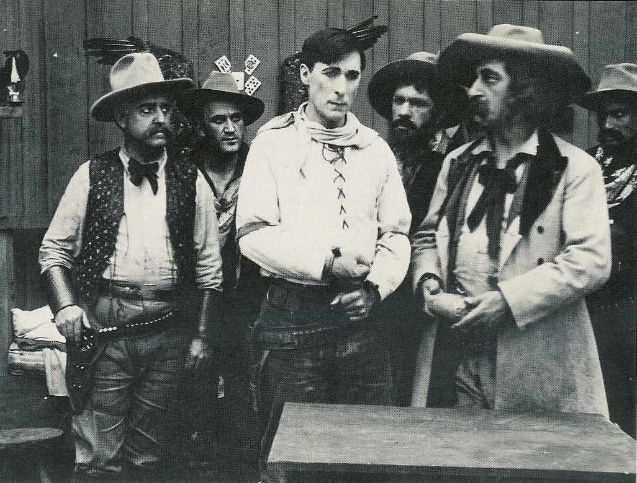
Bill Captured
Bill followed this film with another one of feature length. Then, before either of the latest films was released, Ince informed Bill that he wanted to go back to the short format. To soften the blow, Ince suggested Bill try directing. Bill replied, “If I am to fail, I’ll fail as an actor!” and he returned to his home and his stage career in New York.
That could’ve been it for Bill’s movie career, and he probably would’ve been no more than a footnote in history. Then The Bargain was released! The public and the critics loved it. The critics said it had all the rip-roaring action of a short, but in a long format. The only complaint they had was that in the film, Bill committed something like 6 felonies, and gets away with it! But despite the fear that it might corrupt the youth of America, it was among his most popular movies.
Well, when Ince saw the popularity of The Bargain, he got on the phone and begged him to return. Lucky for us, he did. He took his sister Mary Ellen and his dog Mac, and moved out to California for good. And an interesting side-note regarding the carrot Ince tempted Bill with, directing: when Bill returned, he was the director of his very next film.
If you want to see The Bargain, the only place I know that has it is www.SinisterCinema.com. Their version has a very effective score, and interestingly, you can here projector sprocket sounds in the background. Perhaps it was recorded at a showing of the Bargain, perhaps at it’s rerelease.
Now, I promised you a bargain regarding The Bargain. I contacted Sinister Cinema and they agreed to provide the Friends of Hart Park a 20% discount on all their William S. Hart films, until July 1, 2006. To get the deal, order from Sinister Cinema either by mail, phone of by fax (not the website), and write/mention "Hart Discount" on the order.
Their Hart titles include:
- The Bargain - 1914 (DVD & VHS)
- The Ruse - 1915 (VHS)
- Return of Draw Egan - 1916 (VHS)
- The Square Deal Man - 1917 (DVD & VHS)
- Blue Blazes Rawden - 1918 (DVD & VHS)
- Wagon Tracks - 1919 (VHS)
- The Toll Gate - 1920 (DVD & VHS)
- Tumbleweeds - 1925 (VHS)
Please remember that Sinister Cinema's DVDs are in the DVD-R format, so make sure your DVD player can play those before ordering any DVDs. Visit the website before ordering to download their order form, to get their phone number, to see the prices and synopses, and check out any other sales they're currently running.
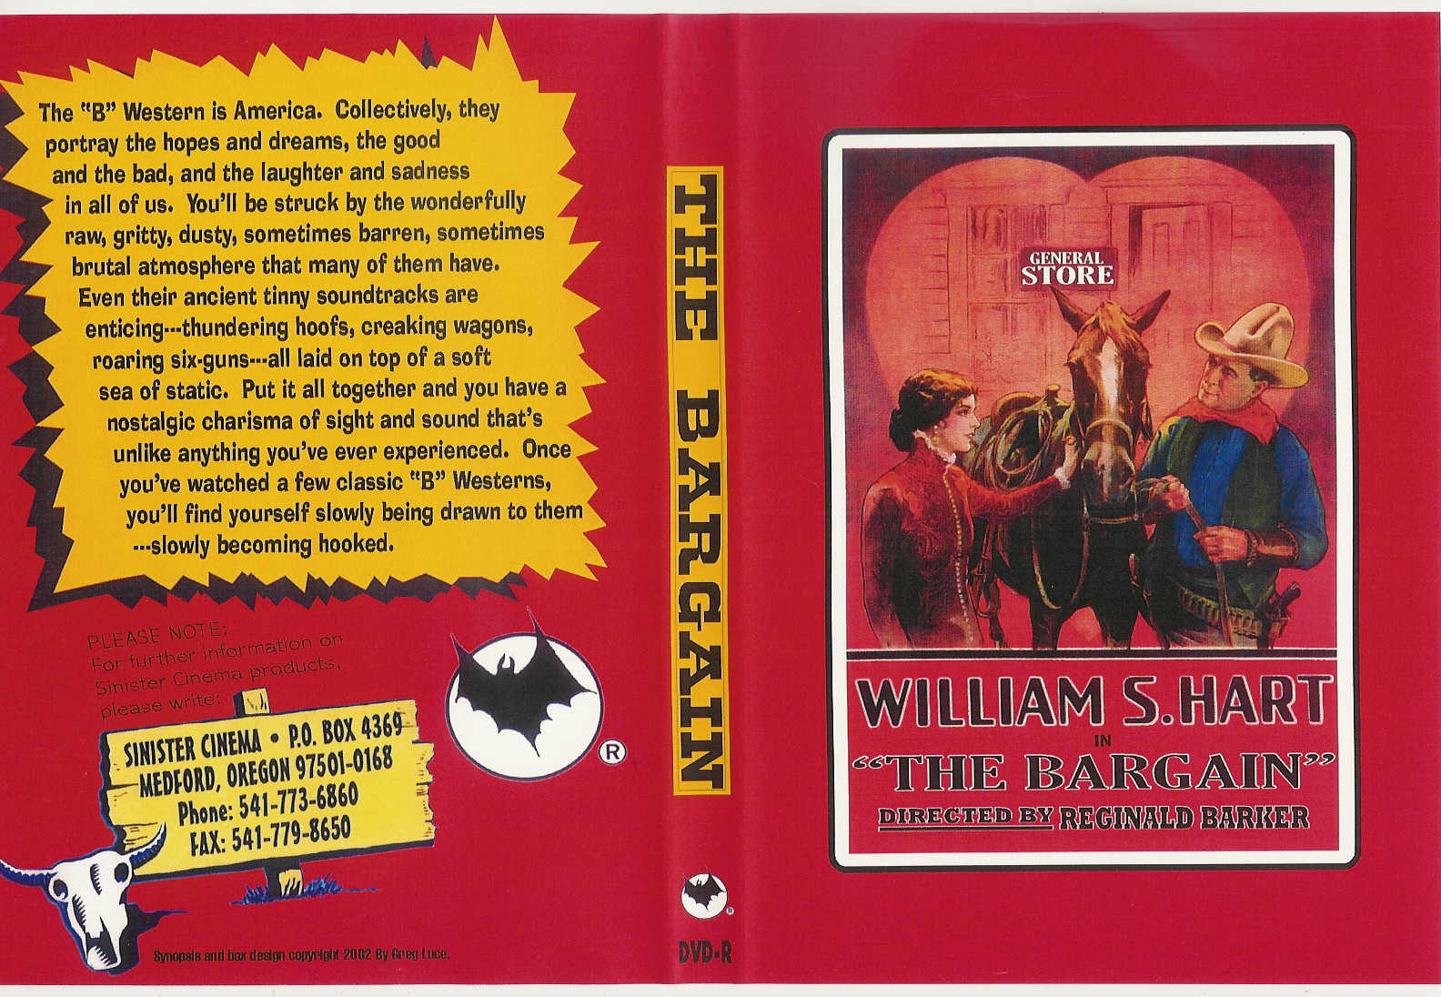
Well amigos, thanks for joining me on another chapter in this DVD Roundup. I’ll be flappin’ my jaws next issue, and hope y’all will join me, with Hell’s Hinges!

